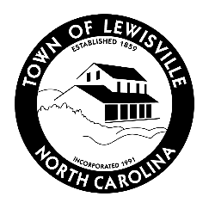
AGENDA
LEWISVILLE PLANNING BOARD
JUNE 10, 2026 AT 6:00 PM
Lewisville Town Hall
1st Floor Council Chambers

- Call to Order
- Roll Call and Determination of Quorum

- Regular Business
- Approval of the Agenda
- Approval of Minutes:
    - April 8, 2026

- Public Comment

- Technical Review
- None

- Legislative Hearings
  - L-117 Conrad Farm North: a request to rezone a parecel of land denoted by the Tax Parcel ID 5877-90-5057, located on the north side of Yadkinville Rd just after the intersection with Robinhood Rd heading west from Agricultural (AG) to Agricultural Conditional (AG-C) for a Planned Residential Development.
  - L-118 Marian’s Landing: a request to rezone seven (7) properties denoted by the principal Tax Parcel ID 5886-56-4784 and six (6) others, located at the southeastern corner of Lewisville-Vienna and Robinhood Roads from Residential Single Family (RS-9) & Manufactured Housing Development (MH) to Residential Single-Family Conditional (RS-9-C) for a Planned Residential Development.

- Continued Business
  - None

- New Business
  - None

- Updates and Review
- Next Planning Board Meetings
- July 8, 2026
- August 12, 2026

- Adjourn

